Robert Neil Nelson
EDIT 720
Dr. Corey Lee
February 14, 2017

OVERVIEW OF FUNDAMENTAL HARMONY LEESON 1
A YOUTUBE VIDEO LESSON ABOUT MUSIC THEORY

Musicologist and music teacher Declan Plummer has created a nine-part series of YouTube instructional videos regarding the fundamental of music theory. These videos are hosted on YouTube (https://www.youtube.com/watch?v=gKKYNj68aCM) and found directly on the author’s website with complimentary worksheets and handouts. These videos would be comparable to the level of instruction provided in a high school Advanced Placement Music Theory course or perhaps even a remedial music theory course offered to music majors at the university level. Music theory is an abstract concept and can be difficult for students with limited prior exposure to the concepts to grasp. As a music teacher, I often compare music theory instruction to math. Both concepts build upon previous learning to build new knowledge. Any deficiencies in the fundamental skills will adversely affect future learning.
A mix of positive and negative aspects of multimedia learning principles can be observed from Plummer’s first lesson titled “The Basics.” I will discuss both aspects along with some suggestions which could improve the effectiveness of Plummer’s materials.
POSITIVES

Perhaps the most positive aspect of Plummer’s lesson is how easy it is to access the material. By posting the information to his personal webpage and to YouTube, it is assured that most every student could access the material so long as an Internet connection is present.

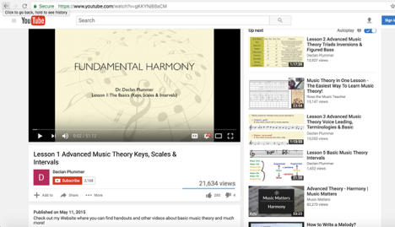
Figure 1: Plummer (2015) fundamental harmony Youtube page

The format of the instructional video is a narrated slideshow. The author narrates and explains the information as slides progressively continue throughout the lesson. The use of a human voice rather than a computer-generated voice has been experimentally shown to be more effective in fostering generative processing (Mayer, 2014). The author speaks in a clear voice and demonstrates effective command in the material through tone and inflection. While the tone does not cross over into a conversational one, I found it to be effective and easy enough to follow.
Throughout the video, Plummer highlights key terms and information to make those pieces stand-out from the surrounding material, following a principle of signaling (Mayer, 2014). This principle says that people learn more deeply from a multimedia message when cues are added that highlight the organization of the essential material. By calling attention to
important materials worth remembering, students are more likely to reduce their level of extraneous processing that can interfere with learning.
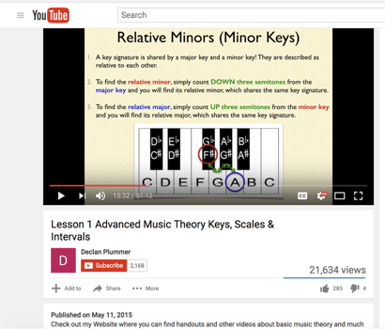
Figure 2: Signaling principle demonstrated in the lesson
A final point worth considering is that the information Plummer presents is factually accurate. This may seem unworthy of mentioning in a critical analysis paper, but I believe it is worth considering since the material is posted online in an environment with no peer review procedures or further verification towards accuracy. The Internet allows anybody with the proper skills to post anything that they desire, whether the information is based in fact or not. I personally reviewed the entire presentation presented by Plummer and can attest that his lesson follows proper music theory protocols and would be a fine tool to use with students if the learning situation were appropriate for its use.

NEGATIVES
The largest negative in this multimedia lesson is the overwhelming amount of material covered in one lesson (see figure 3). For a novice learner, this would almost assuredly lead to extraneous cognitive load and violate many of the principles of effective multimedia design, such as the small step size of knowledge change principle described by Kalyuga (2010). Kalyuga says “the chain of instructional sub-goals and corresponding sequence of learning tasks (should) be defined in smaller step-sizes with manageable load within each step.” As
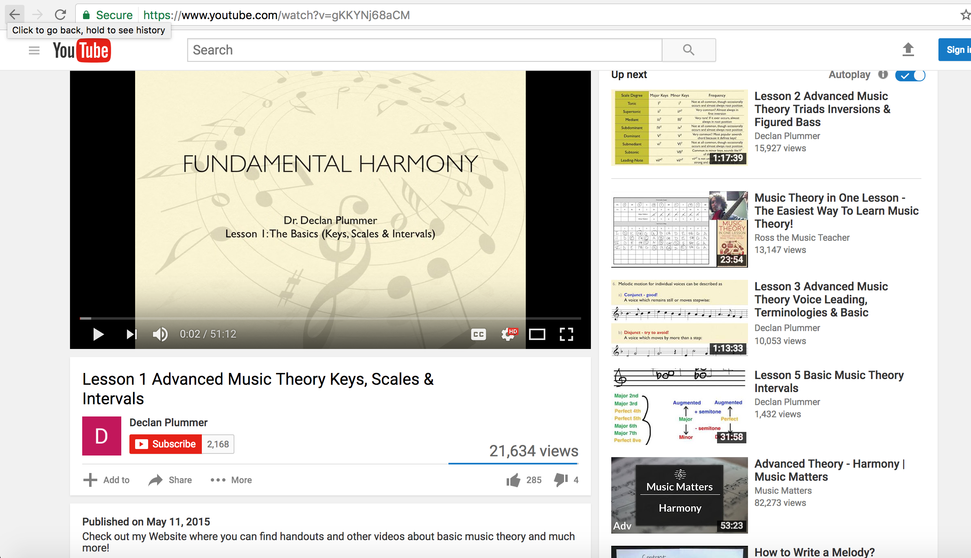
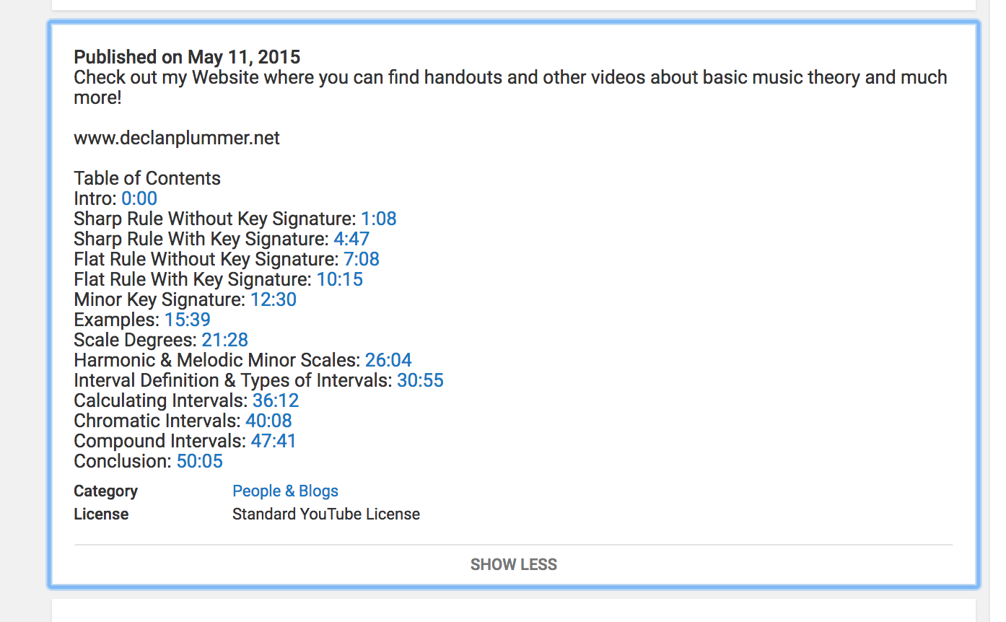
currently constructed, Plummer’s lesson does not provide graduated changes in material presentation as described by Kalyuga. Plummer begins with instruction about key signatures before moving on to scale degrees, major and minor scale tonalities, and intervals. Each of these topics could easily be separate instructional videos as they contain a great deal of material that a novice learner would likely struggle to grasp.
Figure 3: Table of contents for this multimedia lesson
The segmenting principle of multimedia instruction (Mayer & Pilegard, 2014) makes a strong argument for allowing the learner to control the pace of instruction and thereby allowing cognitive processing to occur. While the video has a pause button that a learner could use to stop the material any time they choose, this may not be enough to satisfy the segmenting principle’s main tenet of providing instruction in learner-paced instructional segments. Of greatest note, novice learners may not understand the material well enough to identify logical segment divisions in the presentation, making their use of the pause button ineffective. If the instruction were divided into smaller and clearly defined segments, it may be more effective to the learner.
The multimedia presentation also lacks the ability for students to practice the material before moving on to the next part of the lesson. This is partially a limitation of a video lesson format as opportunities for interactivity are significantly reduced compared to a software application written specifically for the purpose of teaching a particular concept. Without an additional opportunity to interact with the material, it is likely that the material will never pass from sensory memory to working memory where additional processing and storage could occur (Driscoll, 2005). In addition to being limited in terms of engaging with material, video presentations such as this only provide limited functionality for the student.
The extent to which this multimedia lesson activates prior knowledge is inconclusive and largely depends on the learner. A novice music theory student would likely not have prior knowledge activated from this presentation as the lesson immediately begins with instruction of key signatures. This assumes that the learner already has knowledge in reading multiple clefs, identifying notes on the staff, and understanding the relationship of major and minor tonalities. An expert learner in this field, however, would not have the same needs. In this case, the multimedia presentation under discussion could be a great review for the expert learner preparing to undertake more detailed studies. This is important to consider as both schema theory (Anderson, Spiro, & Anderson, 1978) and meaningful learning theory (Ausubel, 1965) place an emphasis on the necessity of activating prior knowledge to reduce cognitive overload. I could easily see a novice learner being overload with the information early in this presentation.
CONCLUSION
Overall, there are a great deal of things to be liked from Plummer’s multimedia presentation. For example, the content is easily accessible and the presentation slides are clear to follow without a lot of distracting extraneous graphics. The content makes sense from a pedagogical perspective and I could find many ways in which to use this work with students. However, there are some important conditions that could limit the functionality and effectiveness of the material. Most notably, this material presupposes that the learner has at least a working knowledge of functional harmony. This makes the material a poor choice for use with novice learners. The lack of segmentation and the large number of topics covered in this instructional sequence would also make this material an unwise choice for low-level learners who may need additional supports in order to learn the material. I think this material would be best suited as a review for music theory students who have already covered a great deal of the material in previous coursework. In that instance, this material would be an ideal tool for activating prior knowledge and readying the mind for learning.

BIBLIOGRAPHY
Driscoll, M. (2005). Meaningful learning and schema theory. Psychology of Learning for Instruction (3rd ed.) (pp. 111-152). Boston, MA: Allyn and Bacon.
Kalyuga, S. (2010). Schema acquisition and sources of cognitive load. In J.L. Plass, R. Moreno, & R. Brünken, Cognitive Load Theory, 48-64. New York: Cambridge.
Mayer, R.E. & Pilegard C. (2014) Principles for managing essential processing in multimedia learning: segmenting, pre-training, and modality principles. In R. E. Mayer (Ed.), The
Cambridge Handbook of Multimedia Learning. (pp. 316-344). New York: Cambridge.
Plummer, C. (2015). Lesson 1: Advanced music theory, keys, scales & intervals. [Video File]. Retrieved from https://www.youtube.com/watch?v=gKKYNj68aCM.
Mayer, R. (2014). Research-based principles for designing multimedia instruction [handout]. University of California Santa Barbara, Santa Barbara, CA.

