Neil Nelson
EDIT 720
Dr. Corey Lee
March 16, 2017
MULTIMEDIA CRITIQUE PAPER #2: MUSICTHEORY.NET
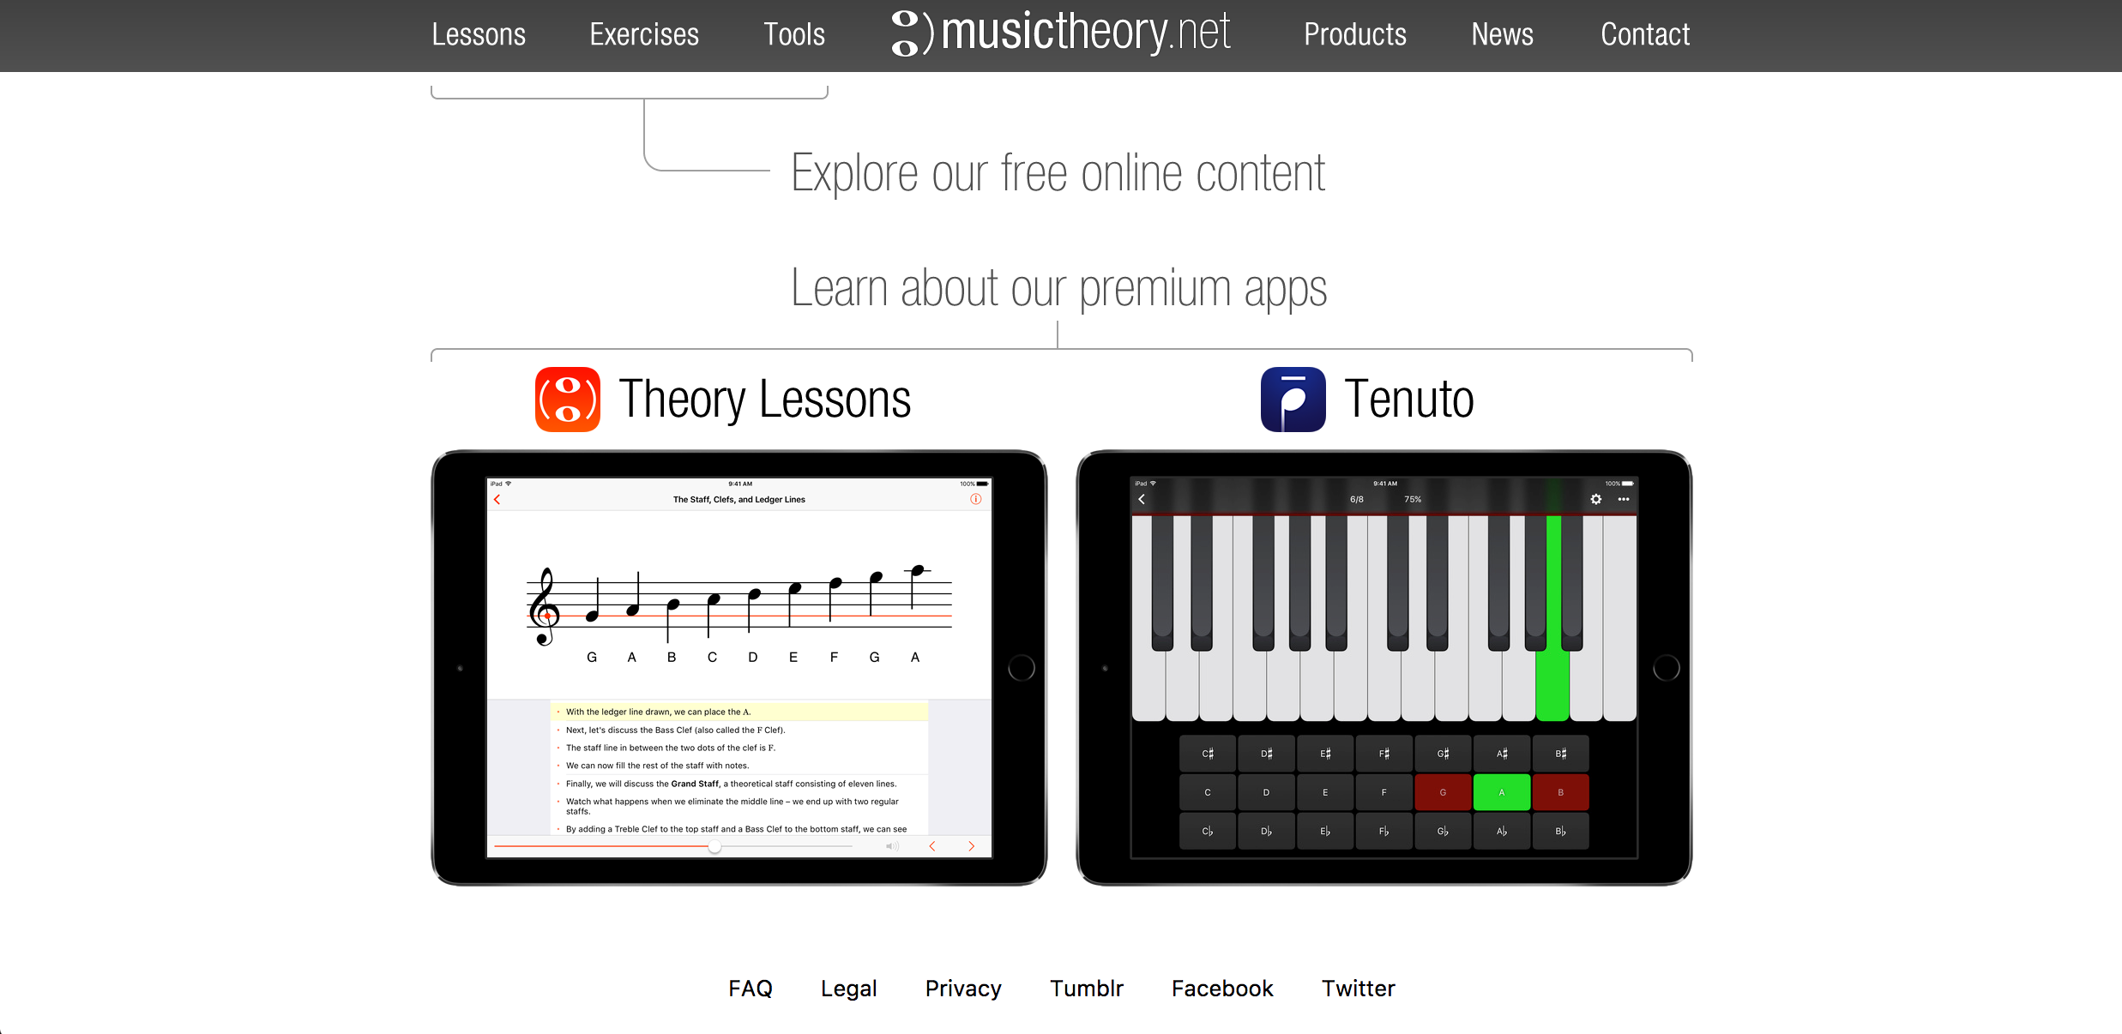
Musictheory.net is a web-based and mobile application resource that presents basic to advanced fundamentals of music theory. This resource is easy to access through any device with an Internet connection and is completely free for the web-based version, although the correlated mobile apps do incur a fee. I have used musictheory.net many times in my career and have found the resource to be easy-to-use with a robust feature set that can be utilized in all music classrooms from beginners to college level theory courses.
Figure 1: the homepage of www.musictheory.net
The features of this service are many, but are predominately divided into sections. These sections are lessons, exercises, and tools. While all three resources are useful and contain a wealth of material, I will focus attention on the lessons piece for the present discussion as it provides the most teaching and learning capabilities. This is not to discount the exercises and tools but simply a function of space limitations in this written format. I will examine both the positive and negative aspects of the lessons presented within this tool in relation to commonly accepted multimedia learning principles along with suggestions which could improve its effectiveness.
POSITIVES
Lessons are divided into 40 topics of music theory, all presented in a multimedia format.
The lessons cover material from the very basic level of identifying notes on the staff to advanced topics such as using Neapolitan chords. Each lesson presents a visual component in addition to incorporating a text narrative piece that explains the material being covered. The user has complete control over the pacing of the lesson with a forward or backward arrow providing movement through the lesson. An audio file will be presented at appropriate points in the lesson to provide an auditory example in addition to the graphical and textural explanation. The user can play the audio file as many times as necessary until they are ready to move on to the next section.
The design of the lessons reflects an understanding by the creators of the multimedia principle (Mayer, 2001) which refers to research suggesting that learning with words and pictures is more effective than learning from words alone. The integration of graphics and audio files into the material is a true strength of the resource. Music theory is an ideal topic in which to use multimedia instruction as the integration of graphical and auditory elements is key in the process of understanding music. Music exists in printed form, but is often experience in auditory form. This combination of elements is a strength of multimedia instruction making it a useful tool for teaching this content.
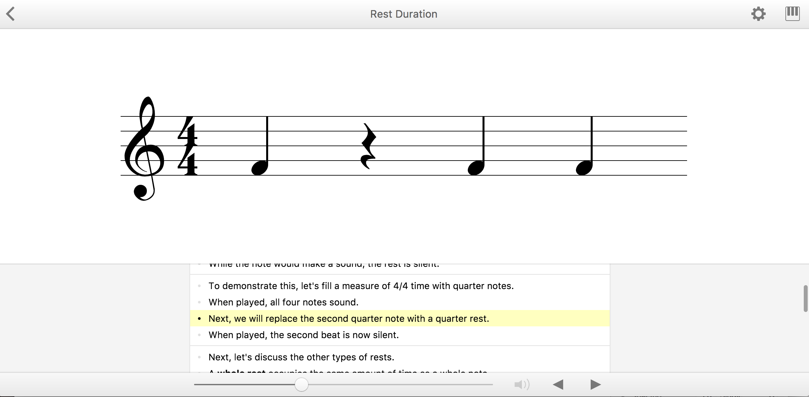
The ability of the user to control the pace of the lesson also conforms with the segmenting principle (Mayer & Pilegard, 2014) which has shown that people learn more deeply when a multimedia message is presented in learner-paced segments rather than as a continuous unit. In this design, the student can take their time to move on once they feel that they have acquired the necessary understanding, as opposed to a continue segment such as a video. The controls to move through the material are simple and intuitive and can be followed without any need for additional instruction as to their use. The controls and basic design of the lessons can be seen in Figure 2, below.
Figure 2: a sample lesson with user controls visible at the bottom

An additional strength of this resource is the use of signaling when needed to draw attention to specific details to aid in understand of concepts. This is based upon the signaling principle (van Gog, 2014), a research finding that shows people learn more deeply from a multimedia message when cues are added that guide attention to the relevant elements of the material. In the example picture below, the red box around part of the graphic highlights the information that is being presented in the text. This helps the learner process the information more efficiently and know exactly where to look for important information related to the content.
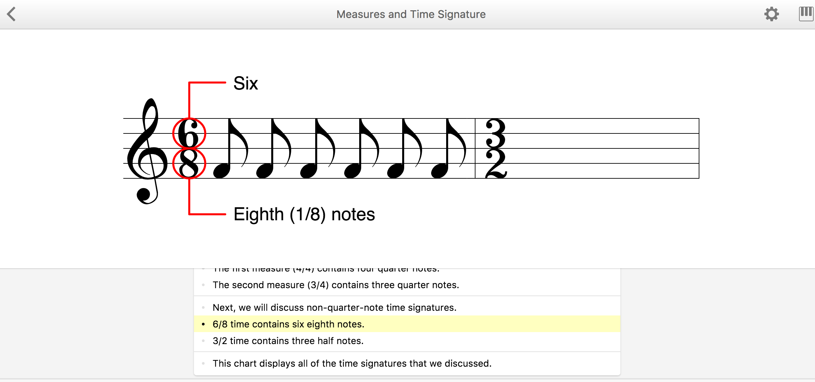
Figure 3: Signaling/cueing within the lesson

NEGATIVES
While overall a superior product, especially for the price point, there are parts of the overall design of the lessons that do not follow best practices as it relates to multimedia instructional design. The most obvious flaw is that the graphics and text are separated with the graphic presented in the middle of the page and the text narration presented at the bottom of the page, a seeming violation of the split-attention principle (Ayres & Sweller, 2014). This principles states that it is important to avoid materials that require earnest to split their attention between multiple sources of information. When using many of the lessons, I found my eyes constantly switching back and forth between the explanatory text at the bottom and the graphic the text was describing in the middle of the page. While I have background knowledge in the topic and this would not be distracting for me, this could lead to an an increase in extraneous cognitive load in the mind of a novice learner. If the authors could find a way to integrate these elements more completely, it is like that the split-attention effect could be avoided.
Second, the use of a written explanatory text as opposed to an auditory narration would violate the modality effect principle (Mayer & Pilegard, 2014). This principle states that people learn more deeply from a multimedia presentation when the words are spoken rather than printed. The reason for this is that printed words combined with instructional graphics only utilize the visual channel of our dual-channel cognitive input system, which can lead to cognitive overload in the learner. If the instruction was presented with auditory narration as opposed to printed word, the material could split the cognitive load between the auditory and visual input channels and free-up valuable cognitive processing power. While the use of audio musical examples is frequent and useful, the clear majority of instruction is delivered by written word. Audio narration may be a superior means of presenting content in this regard.
CONCLUSION
Although some improvements could be made to the design of the lessons to better conform to multimedia principles of design, I feel that musictheory.net is still an excellent multimedia tool to use for the teaching of music theory. This complicated topic easily overwhelms novice learners, but the use of multimedia and user-control over pacing surpasses other multimedia tools that I have encountered. The strengths easily overcome and deficits in overall design. The combination of content, access, and price make this tool one that could be used in a variety of settings to better present music theory concepts to learners.

BIBLIOGRAPHY
Ayres, P. & Sweller, J (2014). The split-attention principle in multimedia learning. In R.E. Mayer (Ed.), The Cambridge Handbook of Multimedia Learning, 206-226. New York: Cambridge.
Mayer, R. E. (2001). Multimedia learning. New York: Cambridge University Press.
Mayer, R.E. & Pilegard C. (2014). Principles for managing essential processing in multimedia learning: segmenting, pre-training, and modality principles. In R. E. Mayer (Ed.), The Cambridge Handbook of Multimedia Learning. (pp. 316-344). New York: Cambridge.
van Gog, T. (2014). The signaling (or cueing) principle in multimedia learning. In R. E. Mayer (Ed.), The Cambridge Handbook of Multimedia Learning, 263-278. New York: Cambridge.

