R. Neil Nelson
EDIT 720
Dr. Corey Lee
April 17, 2017
MULTIMEDIA CRITIQUE PAPER #3
Symphony orchestras around the country can provide a valuable resource to music teachers looking to supplement their classroom teaching with assistance from professional musicians. Many orchestras provide live concert experiences for music classes and routinely host masterclasses for students. In recent years, many symphony orchestras have expanded these offerings into the digital realm with multimedia websites designed to appeal to children related to the symphony orchestra and music in general. One such website that is quite popular among music teachers is produced by the San Francisco Orchestra, titled SFS Kids (www.sfskids.orgs). In this paper, I will provide a general overview of the SFS Kids website and critique it according to principles of good multimedia instructional design. Areas that could be improved will be noted along with the real strengths of this tool.
POSITIVES
The first characteristic that I noticed upon visiting the website is the visual appeal of the design. The webpage resembles a concert stage with red concert stage curtains on either side of the screen which frames the main information in the center while providing a visual cue to the reader about the likely content of this website.
The navigation bar at the top of the webpage lists several options, each providing a different experience. The breadth of musical content covered by this website is quite impressive and includes orchestral music, music history, composers, and instruments. Animated animals such as rabbits conducting an orchestra and foxes wearing formal tuxedos are used throughout

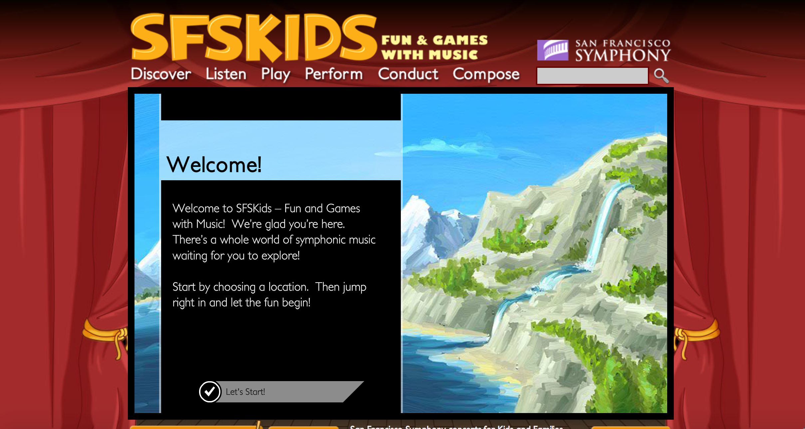
Figure 1: The homepage of SFSKids.org

the application, providing a level of visual appeal to young users (although older students may feel these animations to be too childish). The use of humanlike gestures and movements by the onscreen characters is keeping with the features of the embodiment principle for multimedia learning (Mayer, 2014). The website also follows many characteristics of the multimedia principle, which states that people learn better from words and pictures than from words alone (Mayer, 2001).
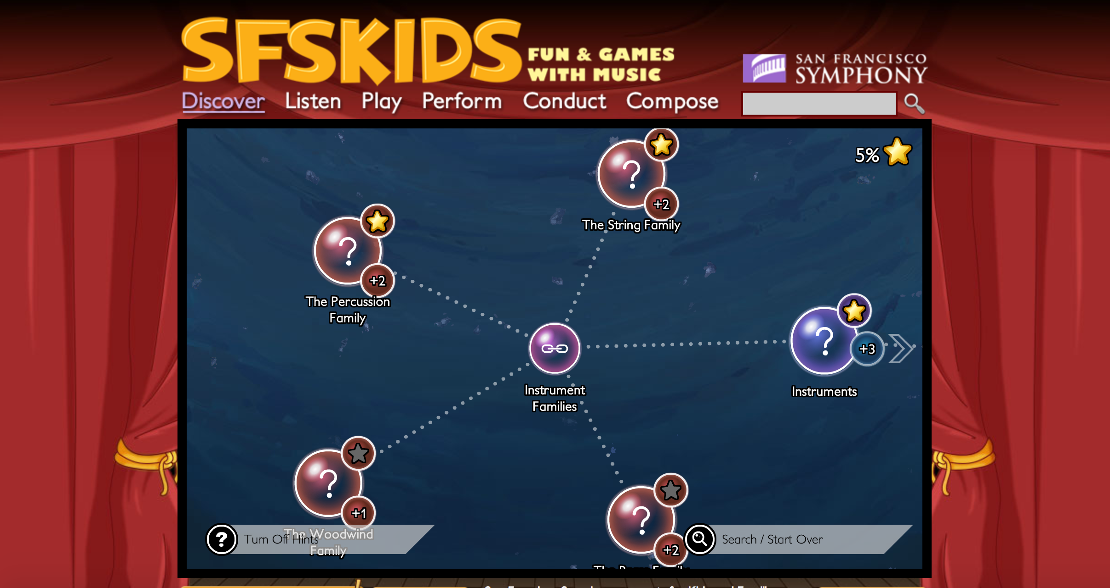
I found the “discover” option to be especially well-designed for students to explore music topic of interest to them. This option is designed to resemble a deep-sea adventure in which students descend below the ocean and can click on different categories that are of interest to them. For example, the initial “dive” into the ocean presents the student with options for composers, music, or instruments. Clicking any of these options will present additional options until the information becomes quite specific. The informational bubbles include text, pictures, and audio examples depending on topic that has been selected. The navigation is easy to follow and the user can jump back and forth between topics as they please. The experience is completely user-directed as these is no set navigational pattern that must be followed which gives the experience a true feeling of discovery. This follows the tenets of the segmenting principle, which states that people learn better when a multimedia message is presented in learner-paced segments rather than a continuous unit (Mayer & Pilegard, 2014). The information is appropriate for the intended audience of elementary school children. The level of detail is just enough to be interesting without becoming overwhelming.

Figure 2: Example from the “Discover” area of website

I also found the “listen” option to be a great tool. This option presents the user with several short clips from the standard orchestral repertoire. Clicking a musical selection plays a short audio clip and displays a brief paragraph describing the music. For each musical selection, the user can select an option to play more music with a similar theme or to play more music by a particular composer. In this way, the user is given complete control to explore music that they find interesting and learn about other pieces of music that share similar characteristics that they may also find appealing. Users earn a gold star for each music selection that listen to in its entirety, providing a motivational piece that a young child would find appealing.
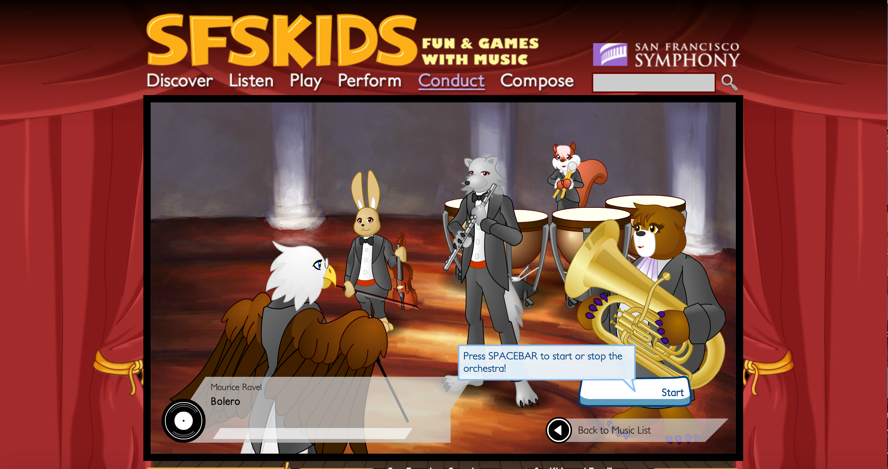
While a majority of this website is completely user-control, there are some aspects in which direct instruction is provided in a more sequential pattern. The best example of this can be found in the “conduct” section. Under this option, the user is provided instruction on how to conduct an orchestra just as a maestro would. By using a mouse to control the hands of the character, the user is able to learn basic conducting patterns. After advancing through the instructional phase, the user is presented with a virtual orchestra to conduct using the procedure previously described. The virtual orchestra responds to the tempo of the user and is an effective means of teaching the role of a conductor in a symphony orchestra and gives the user some practical experience at the same time.
Figure 3: the “conduct” area of the website

Additional options include a “play” area where users direct a a flying avatar to collect passing stars while classical music is played, a “perform” option in which an animated character can be controlled while playing any instrument of the orchestra that is selected by the user, and a “compose” area in which the user can create short melodic lines by selecting note values such as quarter or half notes and dragging them onto a treble clef staff.
NEGATIVES
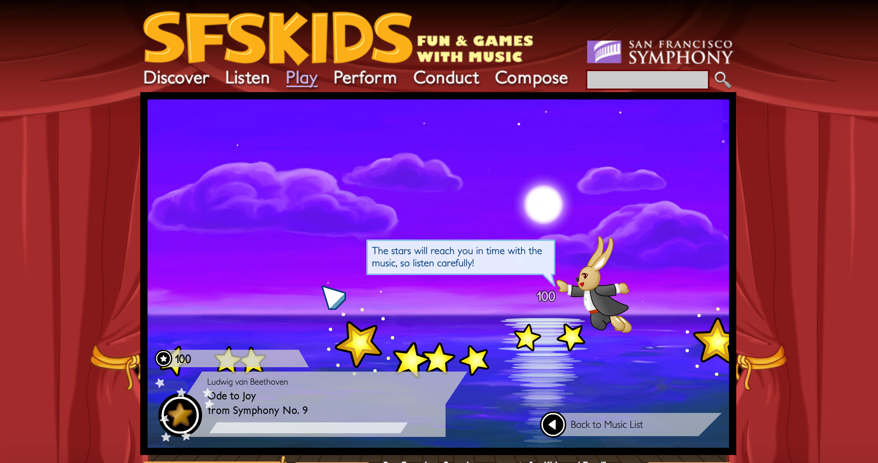
I found the “play” area to lack any real instructional goal and to serve very little purpose. While it may be a fun game to play as the student can fly through the air and collect stars while classical music is playing, there is very little connection to anything of instructional value. The stars do not appear on screen in relation to the music and overall it seems that this was included in the website just for fun. I suppose it is possible that the students may discover classical music that they enjoy from playing this game; however, the “listening” section of the website presents this information in a more thorough manner.
Figure 4: The “Play” area of the website

One principal of multimedia learning that is noticeably lacking is any form of feedback presented to the user. While students are free to create and explore at will, they are not provided any feedback on their creations or provided suggestions for how their work could be improved. If these parts of the resource are the be used, the teacher should be prepared to provide feedback directly to the student.
From a technical standpoint, I had problems getting the “compose” and “conduct” sections to work properly. The entire website is based on flash animation, and although my computer has the latest updates to the flash software, the user controls rarely functioned as intended on my device. After trying several times, I became frustrated and gave up on these tools. Students with less technical knowledge than an adult likely has related to computer usage would also have the same experience. Before using this resource with children, the teacher should investigate the hardware that students will use to access this material and ensure that it is working properly on their device. This is obviously good practice for any multimedia instructional tool.
CONCLUSION
Although a few sections of the website either suffered from technical problems or lack of instructional value, the positives of this website outweigh the negatives. This website could be successfully used with elementary age children to introduce any number of musical topics. The website would be best used as a supplementary tool to allow students the opportunity to explore topics of musical interest related to instructional goals previously introduced in their music classes. The entire website is free to user and does not require any form of payment or registration to access. Overall, this tool from the San Francisco Symphony represents a great resource for teachers of young music students.

BIBLIOGRAPHY
Mayer, R. E. (2001). Multimedia learning. New York: Cambridge University Press.
Mayer, R. E. (2014). Principles based on social cues in multimedia learning: Personalization, voice, image, and embodiment principles. In R. E. Mayer (Ed.), The Cambridge Handbook of Multimedia Learning. (pp. 316-344). New York: Cambridge.
Mayer, R.E. & Pilegard C. (2014). Principles for managing essential processing in multimedia learning: segmenting, pre-training, and modality principles. In R. E. Mayer (Ed.), The Cambridge Handbook of Multimedia Learning. (pp. 316-344). New York: Cambridge.

